

Progress Report

SIDBI – PMU J&K

**Activities Performed by PMU during Dec- 2022**

* PMU in collaboration with MSME-DFO facilitated/organized the MSME EXPO-2022 at Jammu Haat. PMU gave the presentation on SIDBI schemes during that event. PMU organized meeting of various MSEs participants from various states with local associations/presidents benefitted MSMEs of J&K in terms of raw materials & knowledge sharing.
* PMU Organized Awareness Programmes on SIDBI’s initiative in MSME Ecosystem in J&K and its financial schemes in collaboration with Department of SICOP in UT of J&K at different Industrial Estates IGC Lassipora, Wuyann Samba etc –SIDBI financial schemes ARISE, STHAPAN, Green Financing Schemes etc. President IGC Lassipora submitted letter for credit facility of 2000 Crore for upcoming MSME Units in estate to SIDBI.
* PMU also took part in the RBI meeting with SIDBI branch manager (Jammu). There were 20 District team leaders who attended the meeting. We presented out SIDBI Schemes there. Discussed about the SIDBI Schemes there in the forum along with the Branch Manager Jammu.
* PMU also prepared Letter of Intent/MoU Template for agreement with SIDBI and Department of Industries and Commerce to improve institutional credit linkage to MSME’s in the state of Jammu and Kashmir.
* PMU also prepared Letter of Intent Template for agreement with SIDBI and Industrial Association Lassipora-Pulwama one of the Major IA in J&K to improve credit linkage to existing & upcoming MSME’s in the Industrial Estate.
* As a part of immersion program and stakeholder consultation, the team met the Major Industry associations in J&K, like in President of Small-Scale industries Association Gangyal, Industrial Estate Lassipora, Khatua etc for introduction of SIDBI and its Schemes.
* PMU is also working on Baseline Report of MSME across J&K and will submit the report at earliest to Principal Secretary of I&C of J&K UT.
* PMU organized meeting of SIDBI team with IIT Jammu and facilitated IIT-Jammu in submitting Proposals to SIDBI for Support through Seed Funding in Institute Incubation & Innovation Council (I3C).
* PMU also facilitating SIDBI for MOU with Central University Kashmir towards education to entrepreneurship on Skill to entrepreneurship module under Mission Swavalamban.
* PMU organized a capacity building Programme for Artisans towards onboarding products on e-platforms like Amazon, Flipkart, GEM etc
* PMU Organized Udyam Registration Programme for MSMEs in collaboration with Department of SICOP at IGC Lassipora-Pulwama industrial Estates.

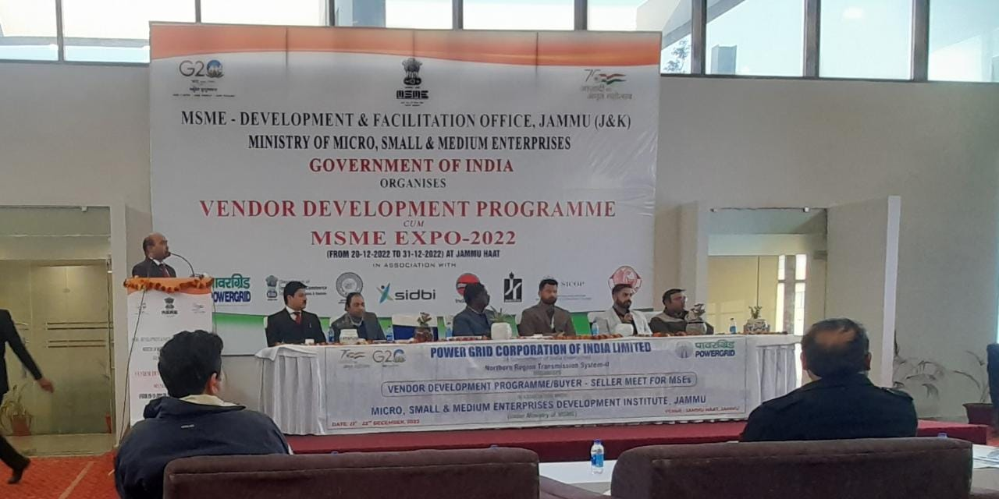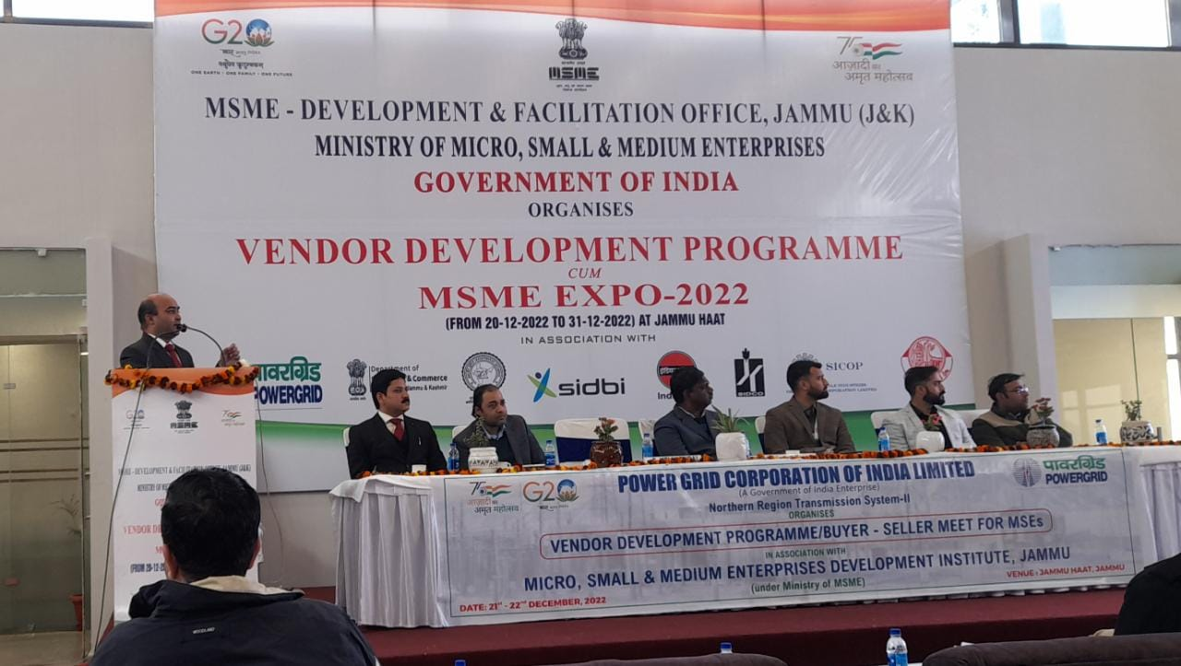

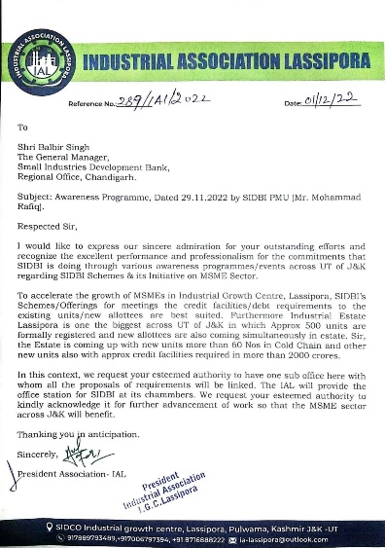

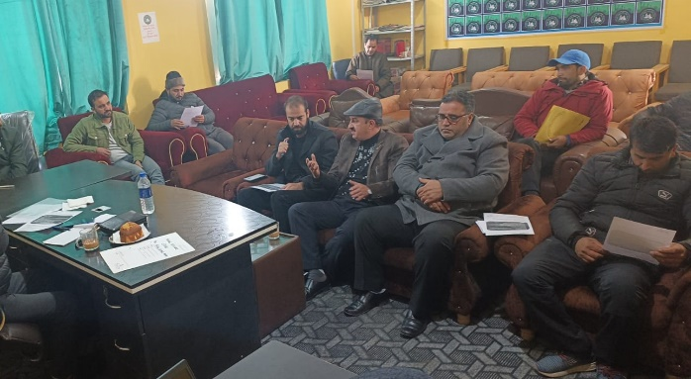

**Contact us**

To know more, please visit [**www.grantthornton.in**](http://www.grantthornton.in/) or contact any of our offices as mentioned below:

|  |  |  |  |  |
| --- | --- | --- | --- | --- |
| **NEW DELHI**  National Office, Outer Circle, L 41, Connaught Circus, New Delhi - 110001 T +91 11 4278 7070 | **NEW DELHI**  6th Floor, Worldmark 2, Aerocity,  New Delhi - 110037 T +91 11 4952 7400 | **AHMEDABAD**  7th Floor, Heritage Chambers,  Nr Azad Society, Nehru Nagar, Ahmedabad - 380015 | **BENGALURU**  5th Floor, 65/2, Block A, Bagmane Tridib, Bagmane Tech Park, CV Raman Nagar, Bengaluru - 560093  T+91 80 4243 0700 | **CHANDIGARH**  B-406A, 4th Floor, L&T Elante Office Building, Industrial Area Phase I, Chandigarh - 160002  T +91 172 4338 000 |
| **CHENNAI**  7th Floor, Prestige Polygon,  471, Anna Salai, Teynampet, Chennai - 600018  T +91 44 4294 0000 | **DEHRADUN**  Suite No 2211, 2nd Floor, Building 2000, Michigan Avenue, Doon Express Business Park,  Subhash Nagar, Dehradun - 248002  T +91 135 2646 500 | **GURGAON**  21st Floor, DLF Square, Jacaranda Marg, DLF Phase II,  Gurgaon - 122002  T +91 124 462 8000 | **HYDERABAD**  7th Floor, Block III, White House,  Kundan Bagh, Begumpet, Hyderabad - 500016  T +91 40 6630 8200 | **KOCH**I  6th Floor, Modayil Centre Point, Warriam Road Junction, MG Road Kochi - 682016  T +91 484 406 4541 |
| **KOLKATA**  10C Hungerford Street, 5th Floor,  Kolkata - 700017  T +91 33 4050 8000 | **MUMBAI**  11th Floor, Tower II,  One International Center, SB Marg Prabhadevi (W), Mumbai - 400013  T +91 22 6626 2600 | **MUMBAI**  Kaledonia, 1st Floor, C Wing, (Opposite J&J Office),  Sahar Road, Andheri East,  Mumbai - 400 069 | **NOIDA**  Plot No 19A, 2nd Floor, Sector - 16A,  Noida - 201301  T +91 120 485 5900 | **PUNE**  3rd Floor, Unit No 309- 312, West Wing, Nyati Unitree, Nagar Road, Yerwada  Pune - 411006  T +91 20 6744 8800 |

For more information or for any queries, write to us at [**contact@in.gt.com**](mailto:contact@in.gt.com)

|  |  |
| --- | --- |
| Twitter-outline | **Follow us @GrantThorntonIN** |

**Small Industries Development Bank of India (SIDBI),** established under an Act of Parliament in 1990, acts as the Principal Financial Institution for Promotion, Financing and Development of the Micro, Small and Medium Enterprise (MSME) sector as well as for co-ordination of functions of institutions engaged in similar activities. In the context of the changing MSME lending landscape, the role of SIDBI has been realigned through adoption of SIDBI Vision 2.0 which envisages an integrated credit and development support role of the Bank by being a thought leader, adopting a credit-plus approach, creating a multiplier effect and serving as an aggregator in MSME space.





***Disclaime****r: This document is prepared under SIDBI intervention in which Grant Thornton Bharat LLP is the implementing agency. The document users/third parties shall verify the facts and figures at their end and shall be solely liable for any action taken by it based on this document. SIDBI, its directors, employees or any office shall not be liable for loss of whatsoever nature arising by using the content of this do*